**Migration of data from HP Quality Center to Rational Quality Management using RQM Migration Utility**

<https://www.ibm.com/developerworks/community/blogs/AshwiniK/entry/may_10_2013_3_04_am?lang=en>

<http://www-01.ibm.com/support/docview.wss?uid=swg21507194>

**Introduction:**

This article is a case study of a task whereby we have migrated around 3000 HP Quality Centre tests to Rational Quality Management (RQM) tool. The HPQC repository contained around 3000 tests going back 10 years. One of the major tasks was to maintain the structural hierarchy to ensure that the users would be able to find things as easily as they previously did in HPQC

The RQM Migration Utility was used to migrate the data. This article is not intended to be a replacement for the documentation that comes with the migration utility which can be found under links given in References section of this article.

Brief about the tools:

**Quality Center (QC)**

Quality Center is a HP product used for maintaining the test management data which contains test scripts, test executions, defects etc.

HP Quality Center has a well-defined hierarchy in which test scripts can be located. Tester creates the test script either with step by step explanation or as a whole scenario. There are user defined sets of attributes for each test scripts which may detail features, releases and so on.

**Rational Quality Management (RQM)**

Rational Quality management is IBM Rational tool used for Test Management; Along with test scripts it supports capability to maintain the test plans and its respective execution records.

There are set of categories tied to the test scripts explaining about the feature/release/automation etc the script belongs to. Provide easy search facility for test scripts. Each test script is having a test case which acts like a container for test script and test case provides the detailed explanation of Test Design, whereas test scripts provides the detailed steps of each step and its Pass/fail criteria. User can even track the actual Results while running test scripts.

Hierarchy levels can be achieved by creating sub categories at any number of levels and the values of parent category are tied to the list of sub categories values to display proper hierarchy of categories at left most portion of Test scripts window.

**RQM Migration Utility**

This is an ExcelExportImport utility, provides capability to import data from Excel file to RQM.

This utility can be installed by just running the .exe provided in Link under References section of this document. After the installation you can see a RQM menu option in your Excel file. Installation directory contains .cfg file where we provide the Excel file column names mapped to the respective fields(category) in Rational Quality Manager .

Following are few steps I performed before starting the actual migration of the data.

**Preconditions:**

* Installed Microsoft Excel
* RQM Migration Utility is installed and RQM option visible in excel file

**Preparatory Work before migration:**

* Quality Centre can have any number of levels in hierarchy.

              For our data it suited to have 3 Levels of hierarchy hence we decided to create maximum 3 levels of hierarchy.

Ex:

Level 1 -> Product Name

Level2 -> Feature Name

Level 3 -> Sub feature

Level4 -> Actual Test Scripts

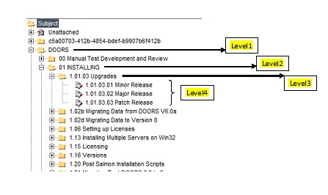

* Create 3 categories in RQM which will represent the 3 hierarchy levels in Quality Center

[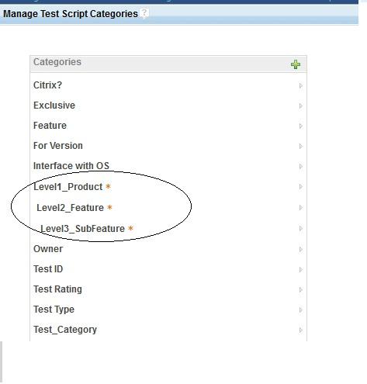](https://www.ibm.com/developerworks/community/blogs/AshwiniK/resource/BLOGS_UPLOADED_IMAGES/a.jpg)

* Create all the required categories in RQM which values will be mapped to fields values taken from Quality Center.

[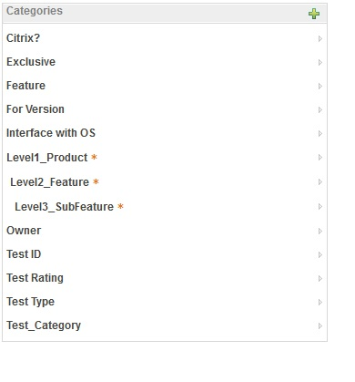](https://www.ibm.com/developerworks/community/blogs/AshwiniK/resource/BLOGS_UPLOADED_IMAGES/a1.jpg)

**Process:**

**[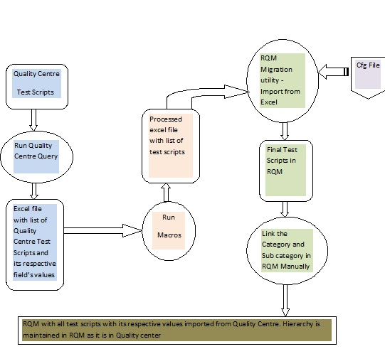](https://www.ibm.com/developerworks/community/blogs/AshwiniK/resource/BLOGS_UPLOADED_IMAGES/a2.jpg)**

**Preparation:**

1. Prepare the query to get list of absolute IDs :

As discussed before we have 3 levels of hierarchy in Quality Centre, when we perform migration of scripts we will be migrating whole set of test scripts that comes under targeted folder at Level2. In order to write a query to pull out list of scripts under specific folder we should know unique identity of that folder. Here in Quality Centre we have absolute IDs to identify folders uniquely.

I executed following query to get list of absolute ID’s on all folders existing in Quality Centre database.

Query is executed from Quality Centre->Dashboard section:

Below screenshot just show how to navigate in Quality Centre to get to the query editor.

Note: Do not use the query in given screen shot, Actual Queries are listed separately in below explanation.

[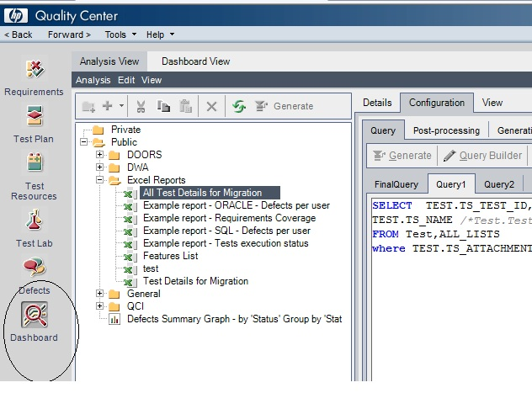](https://www.ibm.com/developerworks/community/blogs/AshwiniK/resource/BLOGS_UPLOADED_IMAGES/a4.jpg)

                                                                                                                                                                                                                                                                                                                            Query to get absolute IDs is below :

*SELECT ALL_LISTS.AL_ABSOLUTE_PATH  /*Test Plan Folder.Absolute Path*/  ,*

*ALL_LISTS.AL_DESCRIPTION  /*Test Plan Folder.Name*/*

*FROM ALL_LISTS*

*Note: Replace the Table and field names in above query with respective names used in your project*

1. Prepare query to get all the test scripts under specific folder at Level2 in Quality Centre to Excel File.

All important required attributes are queried from Quality Centre along with its respective scripts. Following are the list of attributes considered and prepared query:

Note: In below query the value of ABSOLUTE_PATH variable changes depending on theLevel2 folder targeted for migration. Take the absolute path values from the result of query run in Step1.

QUERY:

Select

*ALL_LISTS.AL_DESCRIPTION, /* Level3 Folder Name */*

*TEST.TS_CREATION_DATE, /*Test.Creation Date*/*

*TEST.TS_DESCRIPTION, /*Test.Description*/*

*TEST.TS_RESPONSIBLE, /*Test.Designer*/*

*TEST.TS_USER_04, /*Test.Exclusive*/*

*TEST.TS_USER_14, /*Test.Feature*/*

*TEST.TS_USER_03, /*Test.For Version*/*

*TEST.TS_USER_09, /*Test.Interfaces with O/S*/*

*TEST.TS_STATUS, /*Test.Status*/*

*TEST.TS_USER_02, /*Test.Suitable for Citrix*/*

*TEST.TS_USER_05, /*Test.Test Category*/*

*TEST.TS_TEST_ID, /*Test.Test ID*/*

*TEST.TS_NAME, /*Test.Test Name*/*

*TEST.TS_USER_08, /*Test.Test Rating*/*

*TEST.TS_TYPE, /*Test.Type*/*

*DESSTEPS.DS_STEP_NAME, /*Design Step.Step Name*/*

*DESSTEPS.DS_DESCRIPTION, /*Design Step.Description*/*

*DESSTEPS.DS_EXPECTED, /*Design Step.Expected Result*/*

*TEST.TS_SUBJECT /*Test.Subject*/*

*From Test,All_Lists,DESSTEPS*

*WHERE*

*TEST.TS_TEST_ID =  DESSTEPS.DS_TEST_ID and*

*All_Lists.AL_ITEM_ID = Test.TS_SUBJECT and*

*All_Lists.AL_ABSOLUTE_PATH like 'AAAACPAADAAA%'*

*Order By*

*TEST.TS_TEST_ID,  DESSTEPS.DS_STEP_ORDER*

*Note: Replace the Table and field names in above query with respective names used in your project*

Above are the set of fields we finalized to be required fields for test script hence queried only those from Quality Centre.

1. Prepare a cfg file

             This file is used by RQM Migration utility when we migrate scripts from Quality Center to RQM to map the Quality Center attributes to respective attributes

             created in RQM

a. Every Test script in QC has its respective Test Script and Test Case in RQM.

    All Test Script and Test Cases attributes are covered in this file

b. For every Test script associated Test Case is Created

c. Each Test Case Name is fetched from Excel File and then appended with “_TC”

    Each Test Script Name is fetched from Excel File and then appended with “_TS”

e. Test Script ‘Summary Information’ in Quality Center is copied to Test Design section of a Test Case in RQM

f. In cfg file value of category Level 1 is always DOORS in our case as all scripts under DOORS project are migrated. [DOORS is our product name]

    Level 2 value is hard coded as per which Level 2 folder from Quality Center is targeted from migration.

    Level 3 value is dynamic which is directly picked from Excel file.

 Cfg file Sample is as below:

testscript.XLSStartRow=2

testscript.dc:title=M & "_TS"

testscript.dc:description=M

testscript.XLSArtifactID=M

// the literal "execution" will be put into the step type tag, so all steps will be of type execution

testscript.steps.type="execution"

testscript.steps.description=Q

testscript.steps.title=P

testscript.steps.name=P

testscript.steps.expectedResult=R

testscript.category term="Owner".value=D

testscript.category term="Exclusive".value=E

testscript.category term="Feature".value=F

testscript.category term="For Version".value=G

testscript.category term="Interface with OS".value=H

testscript.category term="Citrix?".value=J

testscript.category term="Test_Category".value=K

testscript.category term="Test ID".value=L

testscript.category term="Test Rating".value=N

testscript.category term="Test Type".value=O

testscript.category term="Level1_Product".value=T

testscript.category term="Level2_Feature".value=U

testscript.category term="Level3_SubFeature".value=A

testscript.jzalm:state="Approved"

testscript.jzalm:Owner="Test"

// a new script starts when we encounter an empty row

testscript.XLSDelimeter=\n

       testcase.ID=testscript.XLSArtifactID

testcase.dc:title=M & "_TC"

testcase.dc:description=M

testcase.Section("myns:com.ibm.rqm.planning.editor.section.testCaseDesign","RQM-KEY-TC-DESIGN-TITLE")=Pre(C)

testcase.category term="Owner".value=D

testcase.category term="Exclusive".value=E

testcase.category term="Feature".value=F

testcase.category term="For Version".value=G

testcase.category term="Interface with OS".value=H

testcase.category term="Citrix?".value=J

testcase.category term="Test_Category".value=K

testcase.category term="Test ID".value=L

testcase.category term="Test Rating".value=N

testcase.category term="Test Type".value=O

testcase.category term="Level1_Product".value=T

testcase.category term="Level2_Feature".value=U

testcase.category term="Level3_SubFeature".value=A

testcase.jzalm:state="Approved"

testcase.jzalm:Owner="Test"

testcase.XLSStartRow=2

testcase.XLSDelimeter=\n

*Note: In this cfg file we are mapping the column names in Excel file to respective fields in RQM. Hence in above cfg content you need to replace the column names (Ex, B, C, N, T…) with respective columns in your excel file*

1. Couple of Macro is run before sending an Excel for migration. These Macros will process data in Excel file and fine tune it to use for migration.

              Following are the Macros used:

            a. Macro to format Summary Information :

            After the data is queried from Quality Center, Summary of Test case includes even the revision history, We wanted only the summary information because

            that was the only useful information by ignoring the Revision History Information

            Macro Sample:

Sub RemoveRevsionHistory()

RowCount = Application.WorksheetFunction.CountA(Range("L:L"))

For i = 2 To RowCount

      s = Cells(i, 3)

     Reply = InStr(1, s, "REVISION HISTORY", 0)

      If (Reply <> 0) Then

                                   s1 = Split(s, "REVISION HISTORY")

                 Else

                                   s1 = Split(s, "Revision History")

                 End If

                Cells(i, 3) = s1(0)

Next i

End Sub

*Note: In above macro replace the column “L” with respective test ID column in excel,*

*Column 3 is used for revision history replace this column number with respective history*

*Column in your excel*

b. Macro to separate the individual test scripts :

During migration the RQM migration utility will consider blank row as a separator between two scripts in excel.

Hence we add a blank line after all the steps of a test scripts are completed.

Macro sample:

Sub AddBlankLine()

RowCount = Application.WorksheetFunction.CountA(Range("L:L"))

RowCount = 3000

For i = 2 To RowCount

   If (Cells(i, 12) <> Cells(i + 1, 12)) Then

       RowCount = RowCount + 1

       i = i + 1

       Cells(i, 1).EntireRow.Insert

   End If

Next i

End Sub

*Note: In above macro replace the column “L” with respective test ID column in excel,*

*Column 12 is used for Test IDs replace this column number with respective Test ID*

*Column in your excel. Here the Rowcount variable value should be changed depending*

*on number of rows exists in your excel file*

c. Macro to replace multi valued attributes values to a single value:

Few fields like “feature” containing multiple values which will make it difficult to search particular script with comma and semicolon in between, So to avoid

this problem, macro is run which will separate the values delimited by comma and considers only first value as the final one.

Macro sample:

Sub MultivaluedAttr()

RowCount = Application.WorksheetFunction.CountA(Range("L:L"))

For i = 2 To RowCount

    s1 = Cells(i, 6)

    Reply1 = InStr(1, s1, ";", 0)

    If Reply1 <> 0 Then

        r1 = Split(s1, ";")

        Cells(i, 6) = r1(0)

    End If

    s2 = Cells(i, 11)

    Reply2 = InStr(1, s2, ";", 0)

    If Reply2 <> 0 Then

        r2 = Split(s2, ";")

        Cells(i, 11) = r2(0)

    End If

 Next i

End Sub

*Note: In above macro replace the column “L” with respective test ID column in excel,*

*Column 6 and Column 11 is used for listing features and components replace this column*

*Number with respective columns in your excel*

d. Macro to remove the appending numbers for feature values :

This step is to remove unwanted data which is not required. Following macro is used to remove appending numbers.

Macro Sample:

Sub RemoveAppendingNumber()

    Dim RE As Object, REMatches As Object

    Dim s As String

    Set RE = CreateObject("vbscript.regexp")

    With RE

        .MultiLine = False

        .Global = False

        .IgnoreCase = True

        .Pattern = ".*[a-z]"

    End With

    RowCount = Application.WorksheetFunction.CountA(Range("L:L"))

    For i = 2 To RowCount

        s = Cells(i, 6)

        If (s <> "") Then

             Set REMatches = RE.Execute(s)

             Cells(i, 6) = REMatches(0)

        End If

    Next i

End Sub

*Note: In above macro replace the column “L” with respective test ID column in excel,*

*Column 6 listing features replace this column number with respective columns in your*

*Excel*

After completing above set of preparation activities we followed the below given sequence of Procedure steps to complete the migration task.

**Procedure :**

1. In Quality Center run query to get Absolute IDs and save the results in AbsoluteID.xls file.

2. Target for a Level 2 folder in Quality Center for migration and grab its Absolute ID from AbsoluteID.xls file.

3. In Quality Center modify the query with respective Absolute ID for Level 2 folder under migration.

4. Run the query to export test scripts to Excel file.

   We have all test scripts and its attributes under the Level 2 folder and all exported to excel file, here each row indicates every step in a test script.

5. On the excel file run Macro 1 to fine tune the Summary information by removing Revision History.

6. Run Macro 2 to add blank line after every test script.

7. Run Macro 3 to fine tune  value of multi valued attribute delimited by comma

8. Run Macro4 to fine tune value of Feature attribute by removing the appending numbers

9. Modify cfg file with the proper value for Level 2 folder

10. Import data in to RQM from Excel file using RQM plugin using the cfg file created for this task.

11. Repeat this whole [procedure for each Level2 folder in Quality Centre

**Problems faced and could not resolve during our case study :**

1. Unable to link the subcategory values with its parent category through migration utility. This was done manually after migration is performed.

2.  Unable to migrate multivalued attributes values

3.  Unable to migrate values to custom attributes in RQM

4. Unable to handle attachments during migration process. This was done manually after the migration completed

5. Call other script within a test script like Keywords are not handled during migration

6. Weight parameter Equivalent to Quality Centre is not found

**References:**

Link to Installation files for RQM Migration Utility

<https://constellation.beaverton.ibm.com/RQM/TMMT/Mainline/N/TMMTMainline-N20111117_0606/cic-metadata/native/>

Link to User Guild for RQM Migration Utility

<https://jazz.net/wiki/bin/view/Main/RQMExcelWordImporter>